

**THE HONG KONG POLYTECHNIC UNIVERSITY**

**BEng Honours Degree in Air Transport Engineering**

**“Interactive Aircraft System Operation and Testing”**

**by**

**WONG Tsz Wa**

**16031963D**

**Report submitted in partial fulfilment of the requirements for the Honours Degree of Bachelor of Engineering in Air Transport Engineering**

**Supervisor: Dr. Pauli Lai (EIE)**

**Industrial Supervisor: Mr. Stanley Tong**

**Date of Submission: 16-04-2018**

# Abstract

Type course is specific course that engineer need to attend in order to certify and release that type of aircraft. And aileron damping test is one of the compulsory items in type course practical training. There is a serious resource problem related to maintenance personnel practical training, which is even though the cost of training with a real aircraft is expensive, trainers cannot achieve the huge efficiency in training trainees through this way. Therefore, maintenance simulation software is now proposed to be a new alternative, which can save the cost by eradicating the need for procuring, operating and maintaining equipment, and help trainers achieve higher efficiency in training trainees by reducing the training time trainees spent in the actual aircraft and shifting more of their practical training course back to the classroom. This paper aims to design maintenance simulation software to provide three methods for trainees to control the remote-controlled aircraft, which simulates the procedures of doing aileron damping test of the fleet in A320 family to help maintenance training organizations save resources in holding type course practical training and achieve higher efficiency in training trainees, and thus support the rapid development of aviation industry. In the design process, I have used Visual C++ in the Visual Studio IDE to create a GUI program, used MIT App Inventor to create a mobile application, and used hot melt glue gun to assemble a remote-controlled aircraft. For the deliverables, users can use the USB port on their computer, the Bluetooth function of their computer, or use the Bluetooth function of their smartphone to control the remote-controlled aircraft.

# Acknowledgement

I am really grateful because I managed to complete my Final Year Project: Interactive Aircraft System Operation and Testing within the time given by my academic supervisor, Dr. Pauli Lai.

First and foremost I would like to sincerely thank Dr. Pauli Lai for the continuous guidance and encouragement among this year. And specially thank to my industrial supervisor, Stanley Tong, a training and development manager in China Aircraft Services Limited (CASL), who gave me this meaningful project and assigned Andy Sit, an engineering trainee in CASL to provide documents and research papers for me to complete my project. This project cannot be completed without the help and support from one of them.

Last but not least, I would also like to express my gratitude to Stanley Tong, Andy Sit Hank Zeng, a Technical Trainer in CASL, Gary Yu, an engineering trainee in CASL together for their willingness to spend time to doing my user acceptance test in CASL on April 10, 2018.

Abstract 2

Acknowledgement 3

Chapter 1 – Introduction 5

Importance of Training 6

Inherent Disadvantages of Practical Training 6

The Alternative 7

Limited Number of Maintenance Simulation Software 8

Chapter 2 – Literature review 9

Show the Importance of my Project 9

Low Profit vs High Fixed Costs 9

Aircraft Maintenance Scheduling vs Flight Scheduling 11

Not Many Choices on Aircraft Age 12

Remuneration for Hard Work 13

Show the Value of my Project 14

Limited Information of Maintenance Simulation Software 15

Formal and Informal Use 19

Cheap but Powerful 20

Suitable for Self-learning 20

Healthy concern 21

Chapter 3 - Project management 21

Chapter 4 – Methodology 24

First stage 24

Second stage 29

Chapter 5 – Results and Discussions 34

Chapter 6 – Conclusions and Recommendations for future work 38

References 40

Appendices 42

# Chapter 1 – Introduction

Importance of Training

Have you ever thought that training is the most important part of sustainable development? As we all know, the aviation industry is now rapidly developed such that the number of passengers to travel keeps on increasing. In statistics, the number of passengers carried by system-wide airlines on scheduled services in 2016 already recorded an increase of 7% over 2015, representing an additional 242 million air trips, and in another 20 years, it is expected to reach 7.8 billion, based on a 3.6% average Compound Annual Growth Rate [1][2]. From this, you probably think that the sustainability of aviation industry is high. However, combined this current situation with the growing problem that countless baby boomers, who are born after World War II generally ranging from 1946 to 1964, have reached their retirement age, it comes as no surprise to know that there will be a serious shortage of workers for the aviation industry in the next decades. Although at this every moment, there are already many teenagers who choose to study discipline related to the field of aviation and have decided to devote themselves to this industry in order to derive benefit from the speedy development of aviation industry, this already gives rise to a concern about whether the civil aviation authorities, maintenance training organizations and governments around the world would be able to efficiently train these new entrants, cause aviation safety has been given very high priority and generally speaking, if the related organizations and authorities cannot provide appropriate training for newcomers such that fatal accidents occur from time to time, the development of aviation industry must eventually become stagnant because of the high accident rate.

Inherent Disadvantages of Practical Training

As a matter of fact, this kind of concern has always existed, but it is necessary. From what I have found in my research, there is already a resource problem, which is related to maintenance personnel practical training. Since even though training with a real aircraft is costly, it does not necessarily mean that trainers can achieve the huge efficiency in training trainees through this way. Actually, training with a real aircraft does have some inherent disadvantages, which are the limited types and size of aircraft, a few experienced trainers and training scenarios provided for the training. As a result, it is definitely time-wasting as trainees must take turns to go inside for the training due to the space limitation, and they cannot solely maintain uncommon type of aircraft or implement specialized maintenance without any help from others during working hours, such as in a maintenance or pre-flight situation, since training with a real aircraft cannot simulate all the issues by considering the time cost and abilities. What is more, some of the maintenance operations may be too dangerous to train. Oppositely, in some cases, procedure errors in practical training may also produce costly components or parts damage.

The Alternative

Therefore, in order to support the rapid development of aviation industry, maintenance simulation software is now proposed to be a new alternative to help maintenance training organizations save more resources and achieve higher efficiency in training trainees while the training will also be certified by civil aviation authorities, since it can save training costs by eradicating the need for procuring, operating and maintaining equipment which is specialized used for training and help reduce the training time trainees spent in the actual aircraft and shift more of their practical training course back to the classroom, in which trainees are free from environmental interference and real-world limitations and they have time to concentrate on instructor-led scenarios and procedure training [13].

Limited Number of Maintenance Simulation Software

However, only proposing is not enough. The current situation I have found is that although there is a lot of simulation software about aviation in the market, ranging from junior level to professional level in different platforms, such as Android, iOS, webOS, Linux, macOS and Windows, a large amount of them only focus on entertainment and flight crew training, instead of maintenance personnel training. And because of this, this project is aimed at designing maintenance simulation software to address the resource problem which is related to maintenance personnel practical training. Considering aileron damping test is one of the compulsory items in type course[1] practical training and the fleet in A320 family is very large such that they have been built 7,820 with a total order of 13,308 as of 31 October 2017, I will create a program which uses together with a remote-controlled aircraft to simulate the procedure of doing aileron damping test of the fleet in A320 family including A318, A319, A320 and A321 to help maintenance training organizations save resources in holding type course practical training and achieve higher efficiency in training trainees, and thus support the rapid development of aviation industry. [3]

**Chapter 2 – Literature review**

**Show the Importance of my Project**

Firstly, since, as I said before in the introduction, the number of simulation software in the market, which is designed for training maintenance personnel, is much smaller than that designed for flight crew training, and training with a real aircraft does have some unavoidable drawbacks, there should be a degree of certainty that the maintenance simulation software is needed to develop. However, it is still not enough to show the importance of my project – design of maintenance simulation software, as there may be an easy way for maintenance training organizations to save the cost of training with a real aircraft, making it unnecessary to transform and develop the maintenance simulation software to support the swift development of aviation industry. Therefore, for further proving the necessity of my project, I have conducted some research to ascertain what exactly the contributing factors in causing the cost of training with a real aircraft being unreasonably high are, and then I will one by one judge whether that there is an easy way for maintenance training organizations to save the cost of training with a real aircraft by controlling or eliminating them. In fact, there are 4 reasons in total I have found out, from my research.

Low Profit vs High Fixed Costs

The first reason is that the profits earned by airlines are generally very low, while their fixed costs are extremely high. As the narrator in a mini documentary called “Why Flying is So Expensive” said, there is so much revenue by airlines to pay off the initial price of the plane than fuel [4]. Actually, I think the real situation is that, more precisely, there is so much revenue by airlines to pay off the fixed costs, causing the profits earned by airlines to rapidly decrease. For example, according to the video, even though an A320 neo at full capacity – 154 passengers flies from New York to Washington, which can bring an income of US$12,320, Delta airlines will only make a profit of US$10 per ticket at most from it, cause it has to paying off all the fixed costs including the initial price of the aircraft, insurance, aircraft maintenance fees, airport parking fees and cost of running the airline, while fixed costs already can sum up to US$7,584.5, taking up 71.5% of total expense of each flight (see Appendix A). This implies that, in order to maximize the income, airlines generally have to schedule the flights well to keep their aircraft operating all the time as much as possible. In case of airlines which want to lease their aircraft to maintenance training organizations to make profit, the aircraft leasing rate is at least larger than the fixed costs of US$7,584.5 for avoiding losses, which shows that aircraft leasing rate is positively correlated with the fixed costs of airlines. Indeed, this example is also a justification to explain why there were so many traditional airlines declared bankruptcy, as a result of emergency of low-cost carriers in these two decades, since most people now pursue high price-performance ratio, instead of blindly focusing on performance, causing traditional airlines to lose a considerable amount of customers. Correspondingly, we can know that the fixed costs of operating airlines cannot easily be reduced by just implementing some measures, and the profits earned by airlines through leasing aircraft or providing scheduled flight service are very low; otherwise, there would not be so many traditional airlines declared bankruptcy in these two decades. This thereby implies that there is no way for maintenance training organizations to cut down the aircraft leasing rate offered by airlines, and thus save the cost of training with a real aircraft, cause the profits earned by airlines through leasing aircraft is already very low because of the high fixed costs.

Aircraft Maintenance Scheduling vs Flight Scheduling

Even worse, the second reason is that the Federal Aviation Administration (FAA) in the United States, or by other airworthiness authorities such as Transport Canada or the European Aviation Safety Agency (EASA) require each airline to have their own Continuous Airworthiness Maintenance Program (CAMP), which includes both routine and detailed inspections, i.e. maintenance checks, to ensure that every aircraft leaving the ground is airworthy, safe and reliable. For your reference, the frequency and required time for different types of maintenance check are listed (see Appendix B). Accordingly, airlines must have their own aircraft maintenance scheduling to assign which aircraft should fly which route and when and where each aircraft should implement various types of maintenance check to minimize the unnecessary maintenance cost and any loss aroused by the re-delegation of another aircraft to the flight, which subsequently causes the available time of their aircraft to become fixed and shorter, and make it harder for airlines to do the flights scheduling. And since the financial burden - fixed costs always exist, this regulation will tend to make airlines to increase the leasing rate, in case of airlines which want to lease their aircraft to maintenance training organizations to make profit [6]. However, obviously, since different types of maintenance checks are explicitly required to implement by civil aviation authorities for aviation safety, there is no way for airlines to skip the routine and detailed inspections to secretly assign flights to their aircraft or lease their aircraft to maintenance training organizations, in order to make extra profit. In other words, in the process, there are also no measures which can be taken by maintenance training organizations to intervene in the increase of aircraft leasing rates offered by airlines or cut down aircraft leasing rate offered by airlines, and thus save the cost of training with a real aircraft.

Not Many Choices on Aircraft Age

Worst still, the third reason is that the monthly rental prices of aircraft offered by aircraft leasing companies are also not attractive, while maintenance training organizations may consider renting aircrafts from aircraft leasing companies if airlines cannot offer an aircraft to them for the practical training in a short time because of maintenance checks.

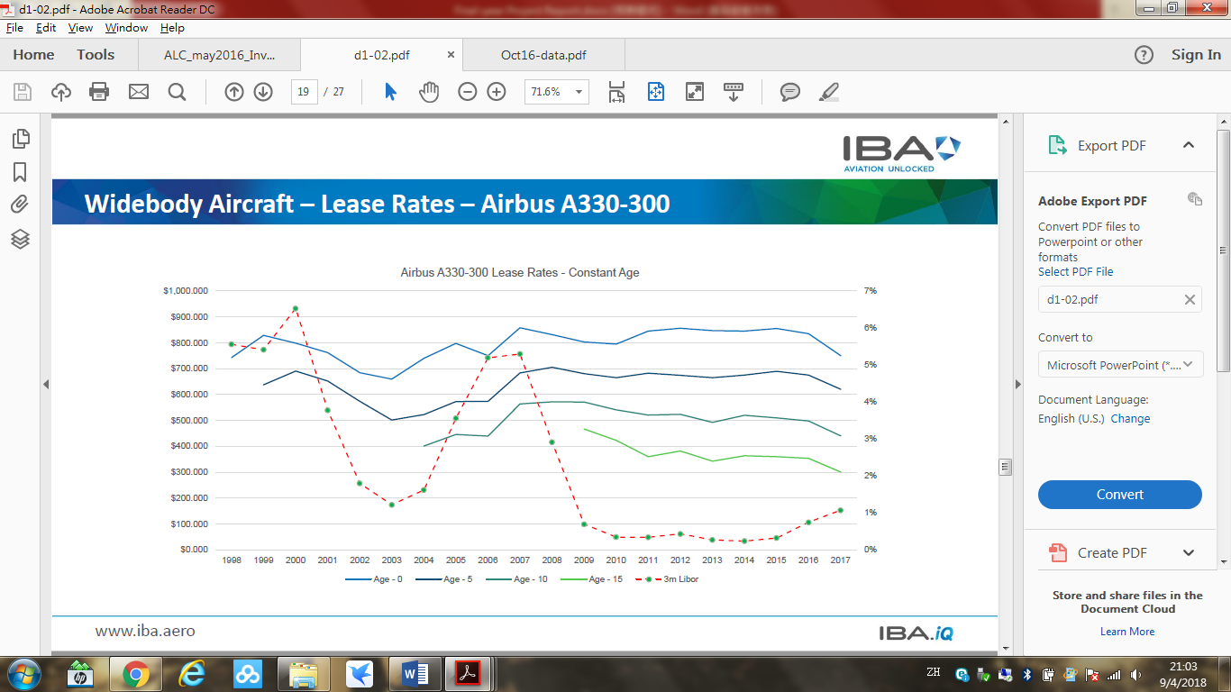

Figure 1. Airbus A330-300 Lease Rates – Constant Age [7]

Generally speaking, the larger the lease rate difference[2] is, the more money airlines or maintenance training organizations can save. Using the Figure 1 provided by IBM, a leading independent aviation consultancy, we can easily know that the largest lease rate difference of Airbus A330-300 in 2017 is as high as 60% since the money for renting it with an age of over 15 years and with an age of 0 year are already given in the above line char. However, since there is rarely a situation where a new aircraft is immediately leased to airlines or maintenance training organizations after release from a factory, and old aircraft will also often be scrapped, there would not be so much choice on the age of rental aircraft. In the real aircraft leasing market, the lease rate ranges of different types of aircraft are generally much smaller, in which the largest lease rate difference is only up to 20% (see Appendix C). And also taking that old aircraft always comes with high maintenance cost and a high fuel burn problem into consideration, it is not challenging for us to recognize that the difference between total expenses of operation of different ages of aircraft is actually not huge, and subsequently that it is not quite possible for maintenance training organizations to save the aircraft leasing rate offered by aircraft leasing companies through renting the oldest aircraft, and thus save the cost of training with a real aircraft.

Remuneration for Hard Work

What is more, the fourth reason is that a lot of hard work is also required by maintenance training organizations to be carried out behind the scenes by other stakeholders, in order to ensure public safety and a better coordination of maintenance personnel training, while the remuneration paid to those stakeholders does count toward the time cost of working with a real aircraft. For example, there are administrative works, which include looking for time slots with aircraft available that suit both the trainees and trainers, and reserving a parking space and aircraft towing tractor, must be done by related administrative officers ahead of the training, while more manpower is needed during the training, such that there are ground staffs to watch out for ground clearance and the operation of aircraft. Although there are many expense items and many different stakeholders involved in this case, since there is a salary level for different posts or tasks, and the remuneration paid to different stakeholders is determined by supply and demand, the remuneration will generally not be adjusted so much unless market conditions change. In other words, similar to the case of second reason, there is no way for maintenance training organizations to cut down the remuneration paid to different stakeholders, and thus save the cost of training with a real aircraft.

Therefore, since it is already proved that the efficiency and cost of traditional training – training with a real aircraft, cannot be improved or reduced anymore by taking any measures to support the swift development of aviation industry, there is now an urgent need for all related stakeholders to put every effort into transforming and developing the maintenance simulation software, and try to keep pace with development of flight simulation software, so that maintenance personnel training can become more efficient while being more cost effective. As far as I am concerned, I have already tried to contribute my part to the community through this project.

**Show the Value of my Project**

Secondly, for proving the my simulation software — GUI program and mobile application which use together with a remote-controlled aircraft is of value to maintenance training organizations, I try to compare the features of my simulation software with that of some maintenance simulation software of similar type in the market to find out the shortcomings among them.

Limited Information of Maintenance Simulation Software

However, as the result of limited number of maintenance simulation software in the market, concerns of business interest, commercial secrets, or even the existence of confidentiality agreement between maintenance training organizations and custom software development firms, there is little information about maintenance simulation software on the Internet and nearly no books written on this topic in contrast to journal article. And what form of information I actually receive from the official website of software are just the brief text description of characteristics and function of maintenance simulation software for most of the time, virtual photograph of the training device for sometimes, and slides of operation for seldom. Nonetheless, I will try my best to sum up the common features of all maintenance simulation software in the market, so that the comparison can be kept going. Note that the features of software which is specified for use with military aircraft maintenance or helicopter maintenance will also be considered.

|  |  |
| --- | --- |
| **Most of Maintenance Simulation Software in the market** | **My Simulation Software** |
| **Feature every part in detail:**  Range from fuselages, wings, engines to fan blade and rivets [9][12][13]. | **Feature a testing procedure in detail:**  One of the compulsory items in type course practical training——Aileron Damping Test.  *There is an interface of mobile application in which trainees can test the both sides of aileron at the meantime for convenience. |
| **Sole learning mode:**  It is only suitable for classroom teaching and at least one instructor is required for the teaching [9][12][13]. | **Mixed learning mode:**  The GUI program and mobile application are suitable for self-learning and with a real remote-controlled aircraft, can also be suitable for classroom teaching. |
| **Locations, dimensions and properties of virtual components match the real part:**  Trainees can become familiar with the actual location of parts and confident in overhauling an aircraft in the event of same failures or errors in the real world [9][12][13]. | **Waiting time and windows matches what primary flight display[3] shows:**  Trainees can be easy to remember the testing procedures they will perform in the real world.  *The waiting time used by mobile application is set to shorter for convenience. |
| **Multiplayer function:**  One instructor and some trainees can be accommodated together [12][13]. | **Exhibition function:**  With a real remote-controlled aircraft, this simulation software can be used as a teaching tool, even for a lecture or speech. |
| **Hardware support:**  Virtual reality controller, touch panel, mouse and keyboard can be used as controllers [10][12][13]. | **Hardware support:**  Mobile phone, tablet, mouse and keyboard can be used as controllers. |
| **2-D animated schematics & 3-D components and tools:**  Any 3-D tools or components, including wiring, tubing and fittings, can be freely moved in any direction, turned to any angle, enlarged or shrunk, cross-sectioned in any direction and cut in any manner in support of the training objectives [10][12][13]. | **2-D primary flight display (PFD) & real remote-controlled aircraft:**  Trainees can have a view angle of up to 360 degrees to look in more detail into the damping motion of aileron of a real model, instead of just looking at video to pursue more realistic experience. |
| **Virtual reality support:**  Trainees can have a fully safe, immersive and interactive learning environment as they can clearly see the inner workings of the aircraft and what the instructor is doing in cramped working space, by simply taking away the outer shells and obstacles in virtual reality [10][12]. | **Equipped with a real remote-controlled aircraft:**  Trainees can have a relatively interactive and fun learning environment while being more cost effective. |
| **Provides instant feedback and remediation advice:**  Help trainees gain required knowledge and skill levels necessary for safe and effective maintenance operations [10][11][13]. | **Have pop-up window to give trainees a warning if they click a wrong button:**  Help trainees memorize which button they should press while doing aileron damping test in the real world.  * All pop-up windows are cancelled on the mobile application to prevent an annoying situation that the pop-up window pops up if trainees always unintentionally press a wrong virtual button. |
| **A wide range of training scenarios:**  Trainees can experience assembly, disassembly and fault isolation of the virtual components, and become familiar with several procedures, such as troubleshooting, maintenance and testing [9][10][11][13]. | **N/A.** |
| **Enable instructors to monitor, control, record and review trainees’ performance:**  Instructors can assign appropriate tasks to their trainees according to the progress and level of trainees [10][13]. | **N.A.** |

Table 1. Comparison between most of maintenance simulation software in the market and my simulation software – GUI program and mobile application.

Formal and Informal Use

As you can see in Table 1, most of maintenance simulation software in the market features every part of aircraft in detail, while my simulation software only features a testing procedure in detail. The reason why I adopt this configuration is because I want to lower the requirements of my software, so that everyone, including maintenance training organizations, individual maintenance personnel, amateur and laymen can afford to use my software for their learning. However, this does not means that my software is informal, in contrast to most of maintenance simulation software in the market, since from the very beginning, what I have designed is actually designing two preferences of learning for users to choose, one for formal learning and the other is for informal learning. Obviously, the GUI program is for formal learning while the mobile application is for informal learning. The main difference between them is that mobile application has unofficial features for another benefits. For example, for convenience, the mobile application allows users to test the both sides of aileron at the meantime, just in one interface, while the GUI program does have two interfaces specified for doing the left or right aileron damping test respectively, in accordance with primary flight display in the real world; Likewise, the waiting time spent by mobile application for entering the testing interface is also set to shorter than that by GUI for convenience. Moreover, it also allows users to freely move the aileron up and down to different positions they want during the testing, for providing further interactive and fun learning environment, while the GUI program taking reference of setting in the real world, there are already two default positions for aileron to move up or down. Therefore, if users prefer formal learning, they can use GUI program to train, or if they prefer informal learning, they can use mobile application to train.

Cheap but Powerful

In fact, when it comes to the deeply comparison between the function of most of maintenance simulation software in the market and my simulation software, as you can see in Table 1, although my software is simple and cheap, it has the majority of common or similar features of all maintenance simulation software. For example, since the interface of 2-D primary flight display designed by me simulates and matches exactly what primary flight display will look like in the real world, it helps users become familiar with and confident in the aileron damping test they will perform in the real world. Besides, as both the GUI program and mobile application use together with a real remote-controlled aircraft, this simulation software can be used as a teaching tool, even for a lecture or speech, similar to the multiplayer function of maintenance simulation software in the market.

Suitable for Self-learning

However, on contrary to most of maintenance simulation software in the market, since my software do not need high-level setup, and using with a real remote-controlled aircraft is just an option for the training, my software is also suitable for self-learning at home, not only limited to classroom teaching. Only need to have my GUI program installed in users’ computer or mobile application installed in users’ smartphone or tablet, users can already practice the steps of doing aileron damping test at anytime, anywhere.

Healthy concern

Besides, it is worth noting that even though most of the software in the market supports virtual reality, it does not mean that virtual reality is the key feature of simulation software. Since if users expose themselves to virtual environment for a long time, some of them may suffer from virtual reality sickness, such as headache, nausea and vomiting, which will discourage them from using the maintenance simulation software. Therefore, it may not be a big problem if I choose to not develop this kind of feature on my software, in order to allow everyone to be able to use it while saving the cost.

**Chapter 3 - Project management**

From the start of my project, I have divided this project into two major stages which are creation of simulation software and development of hardware support, and the duration of each stage is set to be one semester. With regard to which scheduling tools I have adopted on the planning, I actually used one of the most simple but powerful scheduling tool - Gantt chart in the stage 1, as shown in Figure 2, so that I could easily know where my project was headed, what I was doing, for how long I would take for doing it, and how long could the non-critical activities be delayed.

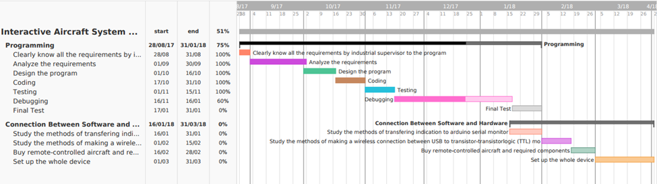

Figure 2. Gantt chart of my project

Fortunately, since I could find that I accomplished the writing and debugging of my GUI program ahead of schedule, by using Gantt chart, and I also wanted to bring further convenience and more choices to the users, a new idea came to my mind, and that was creation of a mobile application which can use the Bluetooth function of smartphone to control the remote-controlled aircraft. With this mobile application, users can also use their smartphone or tablet to control the remote-controlled aircraft, no longer limited to using bulky computer only. Because of this, my new plan is generated and the new schedule is shown in Table 2 with all project milestones.

|  |  |
| --- | --- |
| **Start - End** | **Stage 1** |
| 1/10 – 15/11 | (1) Write a preliminary GUI program which has proper interfaces and design. |
| 16/11 – 7/1 | (2) Debug the GUI Program and implement the final program test. |
| 8/1 – 31/1 | (3) Study how an Arduino unit can communicate and work with some type of external device, such as servo motors and Bluetooth modules. |
| 8/1 – 31/1 | (4) Study how to create a mobile application by myself. |
|  | **Stage 2** |
| 1/2 - 15/2 | (5) Purchase all the required items, such as a remote aircraft, an Arduino unit, two servo motors, a Bluetooth module and two pull rods from either Taobao or Tmail. |
| 1/2 - 5/2 | (6) Create my own electrical circuit |
| 6/2 - 18/2 | (7) Create and verify my own Arduino sketch, and then upload to the Arduino. |
| 19/2 – 7/3 | (8) Design, create and debug my own mobile application. |
| 8/3 - 15/3 | (9) Assemble the remote aircraft and apply mechanical linkage between the servo motors and ailerons. |
| 16/3 - 31/3 | (10) Implement the final project testing and adjust any program codes if needed. |

Table 2. Identification of project milestones

**Chapter 4 – Methodology**

First stage

In the first stage, I have adopted waterfall model to succeed in writing my GUI program using Visual C++ in the Visual Studio Integrated Development Environment, even though there are many other software development models for programmer to follow in programming, such as incremental build mode, agile model, spiral model and software prototype model. Firstly, the prerequisites for I chose waterfall model to write my program was that I had fulfilled all the conditions of using waterfall model, as all requirements by my industrial supervisor Stanley were clearly stated, fixed and understood, and I could get any documents I wanted from his assistant Andy. I was sure that the potential risk of increased costs due to the requirements changed temporarily by my client could be eliminated. Secondly, the advantages of using waterfall model are similar to that of using Gantt chart. Actually, as what it calls, waterfall model is a linear-sequential design approach for software development, in which progress only flows in one direction, like a waterfall, while each phase must be finished before the next phase gets started (step by step) and each phase is discrete, so that achievements can be recognized, as shown in Figure 3 [14].

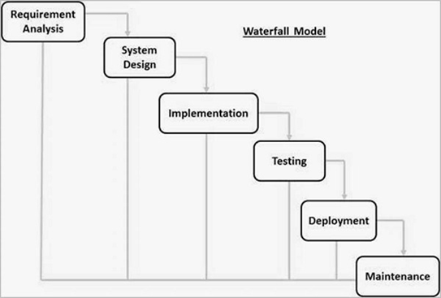

Figure 3. Common phases of water model [14]

Withthe combined use of Gantt chart and water model, I not only could easily know what the progress of my project had been made, but also which phrase my program was progressing in and what should I do in this phase as these two tools complement each other. What I needed to do was simply following the instructions written in an early stage.

Basically, at that time, my GUI program written in the Visual Studio IDE could be run successfully on my computer and the display satisfied the requirements by the industrial supervisor. If users clicked the correct buttons, they could keep shifting to a new windows, and finally they could enter the testing screen as shown in Figure 4, so that they could give indication of what direction the ailerons should move in for testing by pressing the “Up” or “Down” button.

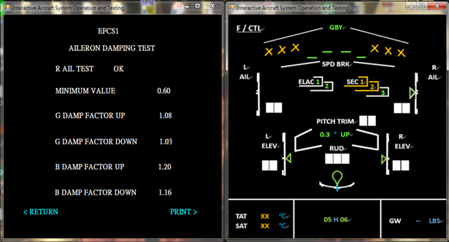

Figure 4. Testing screen of my program

However, I found that it would generate two system errors, causing it couldn’t be executed on another computer which did not have Visual Studio 2017 installed. The two system errors were related to code execution error because vcruntime140d.dll and ucrtbased.dll were missing respectively, as shown in Figure 5 and 6.

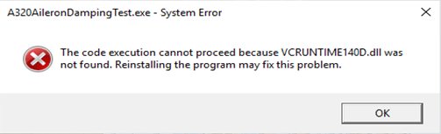

Figure 5. First pop-up error of my program

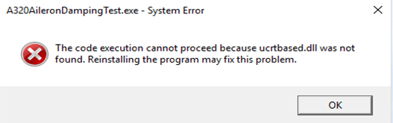

Figure 6. Second pop-up error of my program

Luckily, these two pop-up errors were not difficult to solve. According to Microsoft Developer Network (MSDN), when someone build an application that uses DLLs supplied by Visual Studio, users of the application must also have those DLLs on their computers for the application to run [15]. Therefore, I know that the primary cause of my program not able to be executed on another computer was simply that users missed vcruntime140d.dll and ucrtbased.dll on their computers. Nonetheless, in case of my program which required more DLLs to run in addition to those two DLLs, I also used Dependency Walker, which was a useful tool for troubleshooting system errors related to loading and executing Windows modules, such as exe, dll, ocx and sys, to collect a list of the DLLs that my program depends on, as shown in Figure 7.

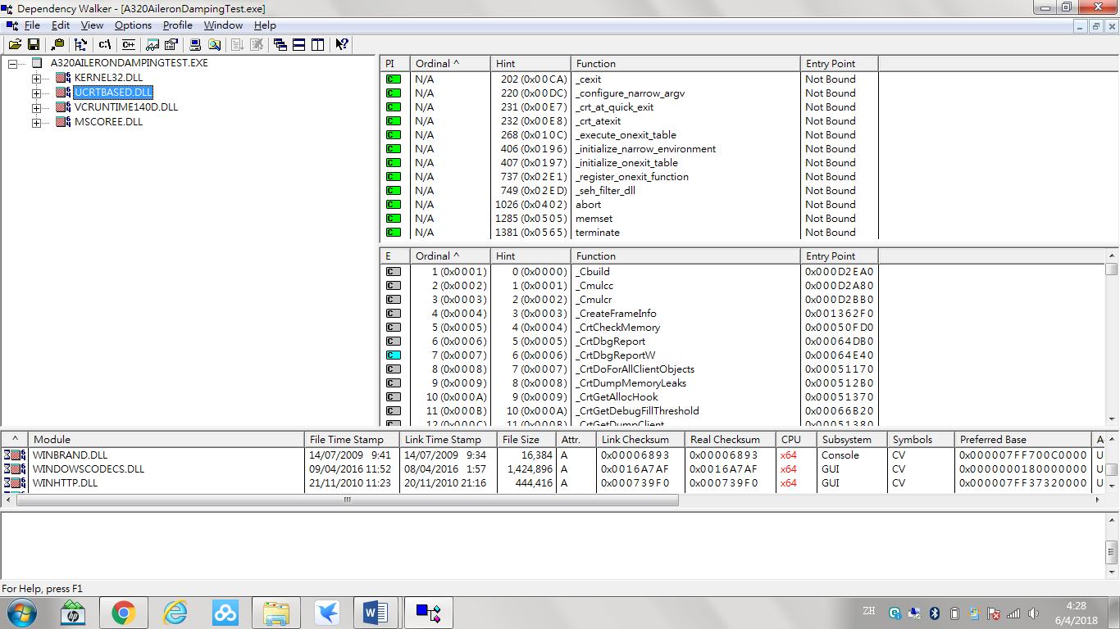

Figure 7. Troubleshooting of my program

Subsequently, I put vcruntime140d.dll, ucrtbased.dll, kernel32.dll and mscoree.dll which were downloaded from the Internet in the same file with my program, and the problem was resolved as expected.

After I successfully debugged the GUI program and implemented the final program test, I started to study Arduino, servo motors and Bluetooth modules on the Internet. In the process, I subscribed several educational YouTube channels, like Mert Arduino and Raspberry Pi to study Arduino programming, and how Arduino could communicate and work with some type of external device, such as servo motors and Bluetooth modules. The videos on those channels helped me understand how to correctly create an electrical circuit between different items on my breadboard and my Arduino's header pins using jumper wires step by step, so that I didn’t need to see the ambiguous and dull Arduino schematics. And one more thing was that the Arduino codes used in the videos were always added to the video description. This saved me the time of creating my Arduino sketch in the later stage since there were some standard headers and codes required for both serial connection and Bluetooth connection.

In addition, I also borrowed several books from Pao Yue-kong Library. I think the most useful book among what I have borrowed is called Sams Teach Yourself Arduino Programming in 24 Hours which is written by Richard Blum. By reading this book, I could learn the basics of Arduino from where I could download the Arduino IDE to prototyping my own projects and by the way reviewed the C programming language. Besides, the writer also introduced the Arduino family in detail. This did help me a lot since at that time I had started looking for an Arduino unit to work with while there were so many different versions of it available on the market.

On the other hand, in the meantime, I started to find a way to create a mobile application by myself, so that users are allowed to use their smartphone or tablet to control the remote-controlled aircraft, no longer limited to using bulky computer only. With God's blessing, I discovered that there was an instinctive programming environment that enabled everyone to create mobile applications for smartphones and tablets at no cost – MIT App Inventor. Since it had blocks-based coding and the live testing function, even children could create their applications to impact the world. And actually, those functions really facilitated the creation of my application in the later stage because they not only simplified the coding process, but also saved me the time of continually moving updated version of Android application package (APK) and installed it to my phone for different testing.

Second stage

In the second stage, I began to purchase all the required items, including a remote aircraft, an Arduino unit, two servo motors, a Bluetooth module, batteries, a battery holder, jumper wires, a breadboard and two pull rods from Taobao. By considering the price, convenience, diversity and inclusion, online shopping was definitely the best choice for me. Actually, I thought the good after-sales service offered by the sellers was also an attractive selling point. And it had been proved to be crucial when I tried to assemble the remote aircraft by myself. In short, I bought a big-sized remote aircraft without any electronic parts, two Tower Pro SG90 servos, a HC-05 Bluetooth module, two steel Z pull rods and finally an Arduino Starter Kit which included all the necessary components, such as a 9V battery, a 9V battery holder, jumper wires and a breadboard.

Then, I more or less successfully designed and created my electrical circuit, Arduino sketch and mobile application in succession since I had a comprehensive plan and I always stuck to it. Indeed, the verification of Arduino sketch and the debugging of mobile application were also a piece of cake. However, there was an unavoidable, but also unsolvable technical problem, which was related to the communication between Arduino and servo motors. According to what I had learnt from the Internet, since servo motors did not have the ability to detect what the position of servo horns was and then returned the feedback to Arduino, Arduino could only unilaterally give command to the servo motors to tell what position servo horns should go to. Under this condition, position mismatch might occur, as there was no detection function to rectify the position of servo horns if servo horns somehow went wrong. As a result, I could not make sure that whenever power was turned on, the position of servo horns would always be in the right position, such that the aileron was in horizontal position.

Additionally. I also encountered an unexpected problem related to the electrical circuit. At that time, the two servo motors suddenly could not follow my command in a smooth way, which really worried me a lot. I thought that the two servo motors or the Bluetooth module might somehow already break down. If this is the case, I had to buy those items again from Taobao. This certainly would waste a lot of time. Fortunately, after I did some research, I found that it was only a power supply problem. The primary reason was simply that the two servo motors run out of battery. Since 9V battery was not suitable to be used in high-drain devices, like servo motors, it would probably run out just in two days for supplying power to two servo motors. Therefore, I immediately went to Sham Shui Po to buy a 4 x AA battery holder and 4 x AA batteries, and this eventually solved my problem and eliminated the worry.

Subsequently, I commenced assembling my remote aircraft. However, after I took out all the pieces as shown in Figure 8, I found that there was no assembly instructions at all and no parts were marked with numbers, and thus I did not know how to assemble it.

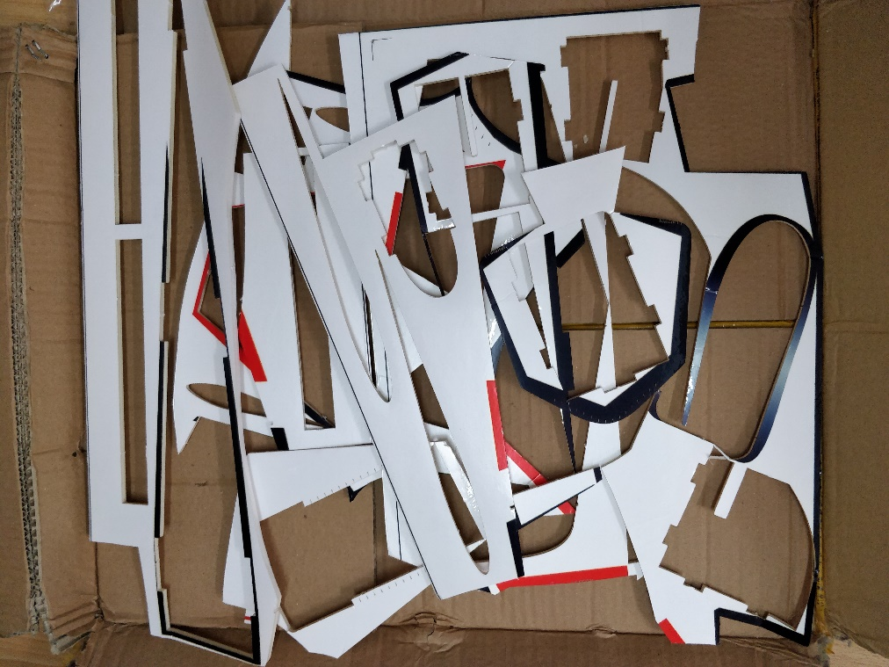

Figure 8. Fragment of the remote-controlled aircraft

Fortunately, as I said before, the good after-sales service offered by the seller should not be overlooked since it did help me resolve my problem. After I asked for help, he/she not only sent me a video clips which clearly showed the assembly procedure of the remote aircraft, but also actively told me that a hot melt glue gun was preferred to use for adhesion. Although it was quite out of my expectation that the assembly required adhesives to bind two separate pieces, this requirement was reasonable since the remote aircraft was cheap but big-sized and the money required to buy a hot melt glue gun for adhesion was much less than the money required to buy a well-structured remote aircraft. And finally, I managed to assemble the remote-controlled aircraft and apply the mechanical linkage between the servo horns[4] of servo motors and ailerons using the two steel Z pull rolls as shown in Figure 9 and Figure 10 respectively.

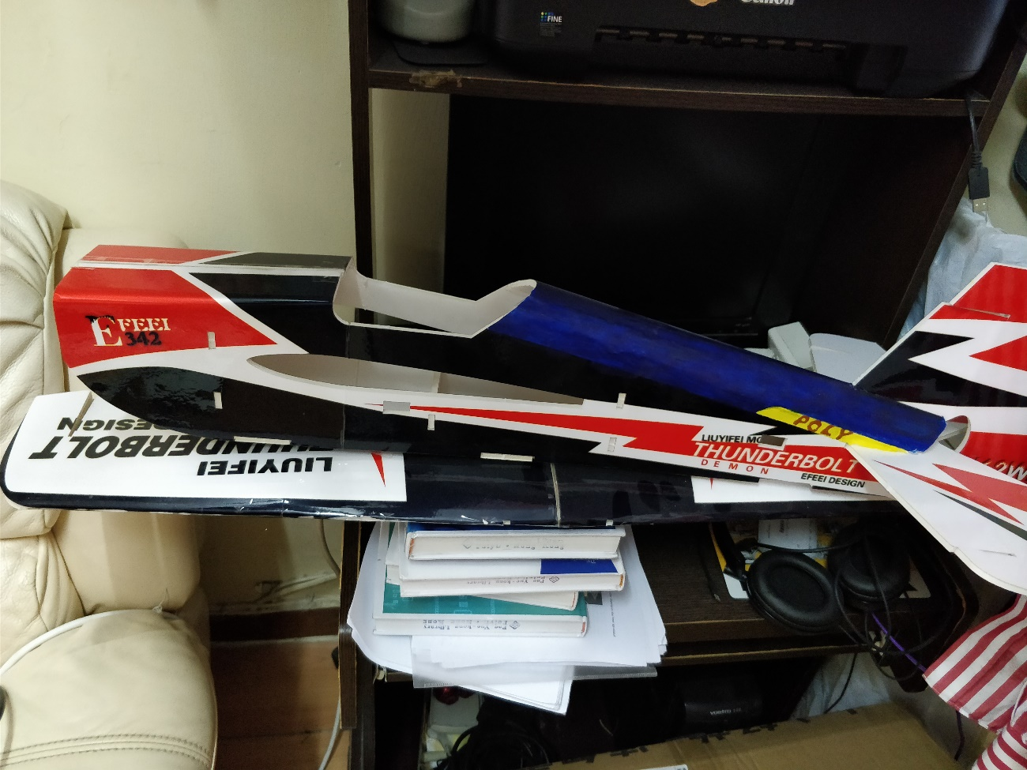

Figure 9. Assembly of the remote-controlled aircraft

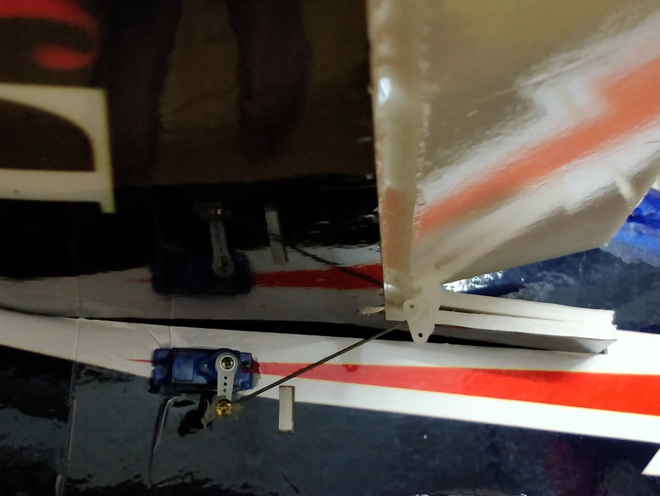

Figure 10. Mechanical Linkage

In the last step, I did the final project testing to determine whether the software and hardware worked well with each other. Additionally, according to the actual movement of the aileron, I also adjusted the code in the Arduino sketch, so that the ailerons would move to the horizontal position whenever power was supplied, and the maximum or minimum damping angle of two ailerons would be the same. The effect diagram of the same maximum damping angle is shown below.

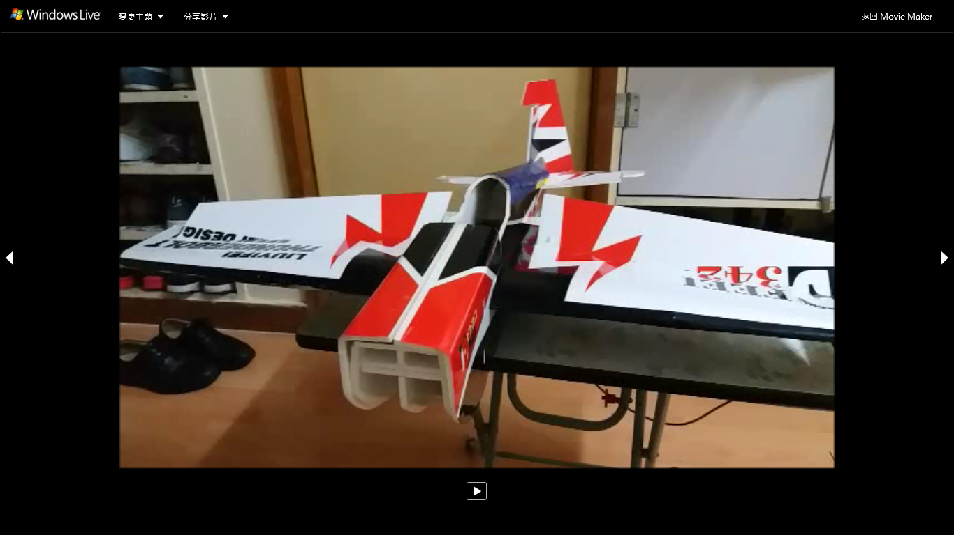

Figure 11. Photo of Final project testing

**Chapter 5 – Results and Discussions**

For better understanding of whether my simulation software can achieve what I and end users – trainees expect, I invited four people who are working at an aircraft maintenance company industry to do my user acceptance test (UAT). Actually, there were two engineering trainees, one engineering trainer, and one training and development manager involved in the test. Since there are three methods for users to control the remote-controlled aircraft, there are also three test cases for them to do, and the aims for each test case is already listed below:

|  |  |
| --- | --- |
| Test case 1: | Verify whether a user is able to enter into the testing interface of aileron damping test and test the aileron successfully from a computer via USB connection. |
| Test case 2: | Verify whether a user is able to enter into the testing interface of aileron damping test and test the aileron successfully from a computer via Bluetooth connection. |
| Test case 3: | Verify whether a user is able to enter into the testing interface of aileron damping test and test the aileron successfully from a smartphone via Bluetooth connection. |

Table 3. The aims for the three test cases

Firstly, for the functional testing part, my simulation software was passed in all the test cases, since the GUI program and mobile application did not crash, while they could accept the correct inputs and give the correct outputs, and behaved exactly as anticipated. And as most interviewees had already watched my demonstration video and seen my user menu, the whole testing process for each test case actually ran very smoothly (see Appendix D).

Secondly, let us shift to the most important part, users’ feedback. In this part, what I am concerned about are whether my software can achieve the objectives and aim of this project. And the result can actually be received through asking meaningful follow-up questions in the user acceptance test, while each follow-up question corresponds to one of aims of this project, as the Table 4 shown below.

|  |  |
| --- | --- |
| **Follow-up questions** | **Aims and objectives** |
| 1. Since you became a maintenance trainee, have you ever encountered difficulty in remembering the procedures of maintenance operations by reading documents? | N.A. |
| 2. Do you think this software is user-friendly and able to help you remember the testing procedures you will perform in the real world? | Help maintenance training organizations achieve higher efficiency in training trainees. |
| 3. Do you think with the real demonstration of a remote-controlled aircraft, can this software be used as a teaching tool, even for a lecture or speech? | Help maintenance training organizations achieve higher efficiency in training trainees. |
| 4. Do you think this whole setup can enable you have a relatively interactive and fun learning environment while being more cost effective? | Help maintenance training organizations save resources in holding type course practical training. |

Table 4. Intent of follow-up questions

Since we have to combine the answer of question 1 and 2 to determine whether my software can support the rapid development of aviation industry, let us have a look at question 2 first. For the question 2, most of the interviewees gave an affirmative answer and only one of them, the engineering trainer hoped this software could develop more functions. However, there was still a consensus that the software offers more chance for trainees to practice and refresh their memory, and thus help them remember the steps. This directly means that my software can actually help maintenance training organizations achieve higher efficiency in training trainees, since it can assist trainees in remembering the testing procedures before they actually do the practical training.

Then for the question 1, both two engineering trainees expressed that they had encountered difficulty in remembering the procedures of maintenance operations by reading documents. This shows that trainees generally have the difficulty in remembering the procedures of maintenance operations by reading documents and really need some kind of software like mine to help them out. Since it is already known that my software can actually help trainees remember the testing procedure they will perform in the real world from the result of question 2, and trainees are the future pillars of aviation industry, giving assistance to them does support the rapid development of aviation industry.

After that, for the question 3, half of the interviewees thought that the software could be served as a prototype and adopted as an in-house training material, and further development would be needed, such as using control interface and aircraft servos, if it was planned to be used as an official type course training material, while the rest of interviewees thought that the software could definitely be used for teaching as the Bluetooth connection was already provided to enable remote-controlled aircraft to circle around in a classroom. This shows that there may be some misunderstanding between my client, CASL, and me since from the very beginning, I have not had any plan to make my software to be official type course training material. What aims I have set is just designing maintenance simulation software to help maintenance training organizations save resources in holding type course practical training and achieve higher efficiency in training trainees. Actually, it would also be accepted that if my software is just used as an auxiliary tool or temporarily replacement by maintenance training organizations, since the software is already of value to them and succeed to help them achieve higher efficiency in training trainees.

Moreover, after you combine the answer of question 3 and 4, it can be sure that there was some misunderstanding between me and my client. Since most of the interviewees gave an affirmative answer for question 4, and only one of them expressed that it would depend on how many functions that can be demonstrated in the software, this directly means that they agree with that the software can be used for demonstration and enable trainees to have a relatively interactive and fun learning environment while being more cost effective, and thus help maintenance training organizations achieve higher efficiency in training trainees and save resources in holding type course practical training.

In summary, my simulation software work very well in the context of maintenance training organization, CASL. It not only runs and behaves exactly as anticipated for the three test cases, but also achieves all the aims and objectives of this project set in the early stage. However, I think this achievement would not be achieved if I did not provide three methods for users to choose to control the remote-controlled aircraft, such that at least one of the method I think would meet their needs and work in the real-world scenarios.

**Chapter 6 – Conclusions and Recommendations for future work**

In conclusion, it is very substantial for me to complete this project. Although I had a comprehensive plan and I always stuck to it, there were still code execution error and power supply problem occurred in my GUI program and electrical circuit respectively. However, all the project milestones were achieved quite smoothly and the problems were eventually solved. For the deliverables, trainees can use the USB port on their computer, the Bluetooth function of their computer, or use the Bluetooth function of their smartphone to control the remote-controlled aircraft, and thereby have a relatively interactive and fun learning environment to remember the procedures of doing aileron damping test while being more cost effective. Eventually, my software achieve the aims and objectives of the project, since according to the result of user acceptance test, maintenance training organizations also think that they can adopt my software to save resources in holding type course practical training and achieve higher efficiency in training trainees, and thus support the rapid development of aviation industry.

For the future development, I think that there could be five main directions of development and they are already listed below.

**1**. The first one is developing more functions, such as adding the control of rudder and updating primary flight display (PFD), so that the software can be used in different teaching aspects, like rudder damping test.

**2.** The second one is extending functionality to other popular aircraft models like Boeing 747, by designing another PFD interface on my GUI program or mobile application, so that my software can become more popularization.

**3.** The third one is using rechargeable batteries as power source to pursue long battery life, so that there is no need for trainees to keep buying new batteries to replace.

**4.** The fourth one is creating a new mobile application, which can run on Apple iOS platforms, so that not only Android users can use my software, but also iPhone users.

**5.** The last one is more hardware support, like supporting virtual reality peripherals, so that trainees can experience how it will take when assembling or disassembling a part since a part can easily be assembled while disassembling it may require taking a lot of effort.

However, I also identify there is one limitation of my software for the future development, which is Arduino could only unilaterally give command to the servo motors to tell what position servo horns should go to, since servo motors did not have the ability to detect what the position of servo horns was and then returned the feedback to Arduino. As a result, the remote-controlled aircraft cannot have some functions, like autopilot mode, since servo motors do not have ability to do self-operation when in the face of disturbance.

**References**

[1] International Air Transport Association. (2017, October 9). *More than 7% increase in Air Travel Compared to Last Year* [Press release].Retrieved from <http://www.iata.org/pressroom/pr/Pages/2017-10-09-01.aspx>

[2] International Air Transport Association. (2017, October 24). *2036 Forecast Reveals Air Passengers Will Nearly Double to 7.8 Billion* [Press release]. Retrieved from

<http://www.iata.org/pressroom/pr/Pages/2017-10-24-01.aspx>

[3] ORDERS & DELIVERIES. (2017, Oct). *AIRBUS*, Retrieved from

<http://www.aircraft.airbus.com/market/orders-deliveries/>

[4] Plush, H. (2016, May 23). Revealed: What airlines really spend your money on? *The Telegraph.* Retrieved from

<https://www.telegraph.co.uk/travel/travel-truths/what-airlines-really-spend-your-airfare-money-on/>

[5] Aircraft maintenance checks. (2016, May). *Aircraft Engineer info,* Retrieved from

<http://www.aircraftengineer.info/aircraft-maintenance-checks/>

[6] C. Sriram & A. Haghani (2003). An optimization model for aircraft maintenance scheduling and re-assignment: Transportation Research Part A, 37, 29-48.

[7] Yeomans, M. (2017, May). Global Market Outlook: Commercial Aircraft and Leasing. Paper presented at the Conference on College Composition and Communication Convention, UK

[8] Values and Lease Rates (2016, October). *International Bureau of Aviation,* Retrieved from <https://www.iba.aero/wp-content/uploads/2016/12/Oct16-data.pdf>

[9] Apache Virtual Interactive Environment. (2018). *LSI,* Retrieved from

<http://www.lsijax.com/products-services-categories/virtual-interactive-training/?client=20>

[10] Virtual Maintenance Trainer. (2017). *ST Electronics,* Retrieved from

<https://www.stengg.com/media/30200/virtual-maintenance-trainer-brochure.pdf>

[11] Virtual Maintenance Training Systems. (2018). *Havelsan,* Retrieved from

<http://www.havelsan.com.tr/en/trainning-and-simulation-technologies-virtual-maintenance-training-systems>

[12]Dassault Introduces 3D Virtual Reality Technology for Immersive Maintenance Training Tool. (2017, Feb). *Dassault Aviation*, Retrieved from

<https://www.dassaultfalcon.com/en/MediaCenter/Newsd/Pages/PR%202017/Immersive-maintenance-training.aspx>

[13] Virtual Maintenance Trainer. (2018). *L3 Commercial Training Solutions,* Retrieved from

<https://www.l3cts.com/training-systems/maintenance-products/virtual-maintenance-trainer>

[14] Waterfall Model. (2018). *Tutorials Point,* Retrieved from

<https://www.tutorialspoint.com/sdlc/sdlc_waterfall_model.htm>

[15] Determining Which DLLs to Redistribute. (2018). *Microsoft Developer Network,* Retrieved from

<https://msdn.microsoft.com/en-us/library/8kche8ah.aspx>

**Appendices**

Appendix A

Expense Item of Delta Airlines [4]

|  |  |
| --- | --- |
| **A320 neo (** Average fare of flight from New York to Washington : US$80) | |
| Paying off price of plane | US$1,771 per flight |
| Plane insurance | US$38.5 per flight |
| Crew salaries (1 pilot, 4 cabin attendants) | US$231 per flight |
| Aircraft maintenance fees | US$2,156 per flight |
| Airport parking costs | US$2,079 per flight |
| Taxes and charges | US$2,402 per flight |
| Fuel | US$385 per flight |
| Cost of running the airline | US$1,540 per flight |

Appendix B

Frequency and Required Time for Different Types of Maintenance Check [5]

|  |  |  |
| --- | --- | --- |
|  | Frequency | Required time |
| Type A check | Every 400-600 flight hours | 20-60 man-hours |
| Type B check | Every 6-8 months | 1-3 days /120-150 man-hours |
| Type C check | Every 20-24 months | 1-2 weeks / 6000 man-hours |
| Type D check | Every 6 years | 2 months / 50000 man-hours |

Appendix C

Values and Lease Rate of commonly traded aircraft (199X-2016) [8]

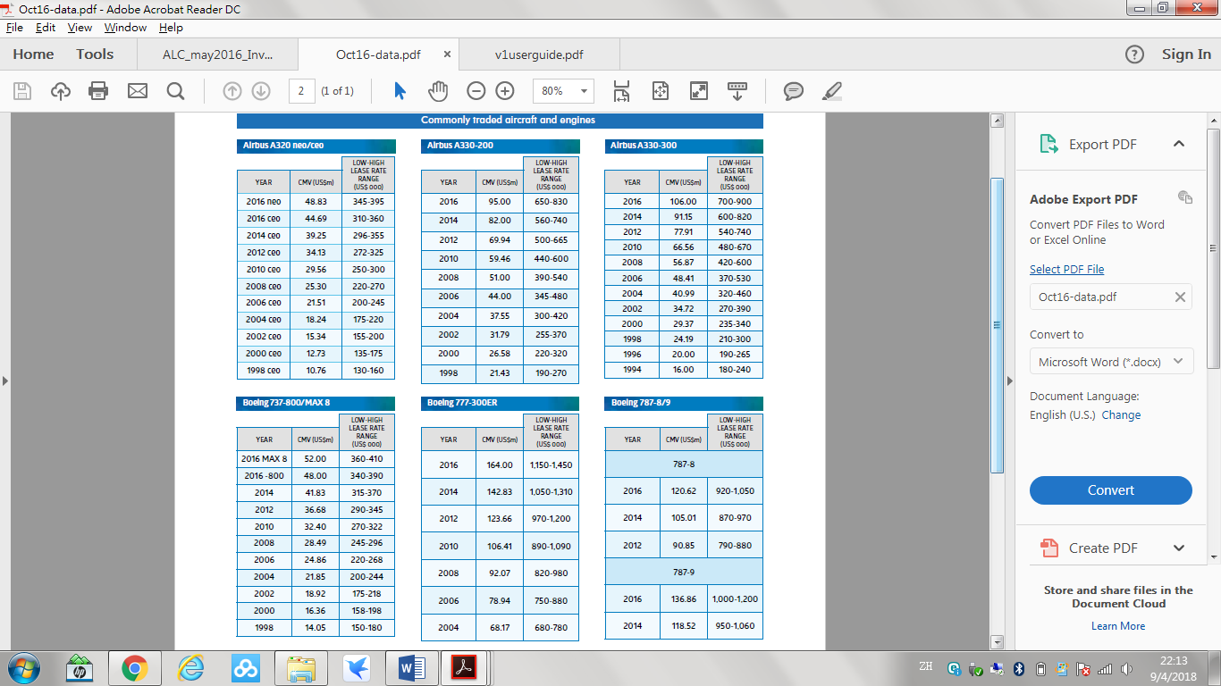

Appendix D

User Menu [Myself: <https://youtu.be/7BH5Dj64REM>]

[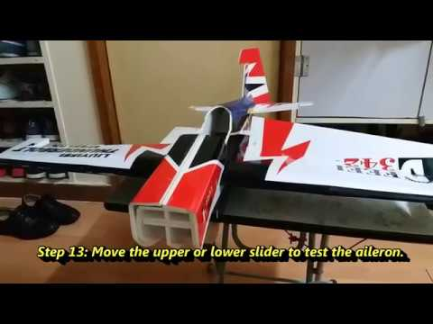](https://www.youtube.com/watch?v=7BH5Dj64REM)

**Version 1: Use the USB port on your PC**

Step 1: Plug the USB cable from the remote aircraft (Arduino) into a USB port directly on your computer.

Step 2: Open the A320AileronDampingTest.exe which is inside "A320AileronDampingTest" file.

The followings illustrates the steps of doing aileron damping test.

Step 3: Click the "SYSTEM REPORT / TEST" button.

Step 4: Click the "EFCS 1" button.

Step 5: Click the "TEST" button.

Step 6: Click the "AILERON DAMPING TEST" button.

Step 7: Click the selected option to enter into the corresponding testing interface. (You can select Left / Right aileron for Testing.)

Step 8: Open Device Manager to determine the COM port number of the Arduino.

Step 9: In the Device Manager list, look in Ports and find the Virtual COM port, which was created by the Arduino.

Step 10: Pick the right COM port number of the Arduino.

Step 11: Enter "Up" or "Down" arrow key to test the aileron.

**Version 2: Use the Bluetooth function of your computer**

Step 1: Plug the USB cable from the remote aircraft (Arduino) into any power bank.

Step 2: Open Devices and Printers and click "Add a device" button.

Step 3: Pick the HC-05 device and enter the pairing code : 1234.

After the installation of HC-05 device driver:

Step 4: Right click the HC-05 device, then choose the "Content" option.

Step 5: Click the "Service" layout and you will see the Virtual COM port number which was created by HC-05 device.

Step 6: Open the A320AileronDampingTest.exe which is inside "A320AileronDampingTest" file.

The followings illustrates the steps of doing aileron damping test on primary flight display.

Step 7: Click the "SYSTEM REPORT / TEST" button.

Step 8: Click the "EFCS 1" button.

Step 9: Click the "TEST" button.

Step 10: Click the "AILERON DAMPING TEST" button.

Step 11: Click the selected option to enter into the corresponding testing interface. (You can select Left / Right aileron for Testing.)

Step 12: Pick the right Virtual COM port number of the HC-05 device.

Step 13: Enter "Up" or "Down" arrow key to test the aileron.

**Version 3: Use the Bluetooth function of your smartphone**

Step 1: Plug the USB cable from the remote aircraft (Arduino) into any power bank.

Step 2: Move the A320AileronDampingTest.apk which is inside "Android App apk" file to your Android phone.

After picking up your smartphone:

Step 3: Install the apk on your Android phone.

Step 4: Go to the Bluetooth setting.

Step 5: Turn the Bluetooth wireless function on and match the HC-05 device by entering the pairing code : 1234.

Step 6: Open the "A320AileronDampingTest" app.

The followings illustrates the steps of doing aileron damping test.

Step 7: Press the "SYSTEM REPORT / TEST" virtual button.

Step 8: Press the "EFCS 1" virtual button.

Step 9: Press the "TEST" virtual button.

Step 10: Press the "AILERON DAMPING TEST" virtual button.

Step 11: You can press "START LEFT AIL TEST" or "START RIGHT AIL TEST" virtual button as you will enter into the same testing interface.

Step 12: Touch the Bluetooth Logo and select the 00:18:E4:03:51:7C HC-05 to build the Bluetooth connection.

Step 13: Move the upper or lower slider to test the aileron.

**Troubleshooting:**

**If you cannot test the aileron by your device, the most likely problems are:**

For all the setups:

* The USB cable from the remote aircraft (Arduino) may not be properly connected to a USB port directly on your computer or power bank. Make sure the connection is successful established before you go to the next step.

For the use of USB port on your PC:

* You may not pick the right COM port number of the Arduino on your computer. Make sure you pick it right.

For the use of Bluetooth function:

* Your device may not have Bluetooth wireless function on.

Make sure you see a  symbol at the top of the screen on your phone or on the taskbar of your computer.

* Your device may not pair the HC-05 Bluetooth module. Make sure you pair them by entering the pairing code : 1234.
* You may not pick the right Virtual COM port number of the HC-05 device on your computer or select the right 00:18:E4:03:51:7C HC-05 option on your phone. Make sure you pick them right.

1. Type course : specific course that engineer need to attend in order to certify and release that type of aircraft
2. Lease rate difference: the difference between the amounts of money paid over a specified time period for the rental of two assets.
3. Primary flight display: an aircraft instrument designed to show flight information during flight.
4. Servo horn: A small nylon or plastic arm or wheel that attaches to the output shaft of a servo, the purpose of which is to connect the servo to whatever control linkage necessary.